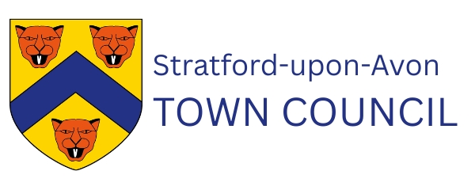
Role: Deputy Chief Officer
Location: Stratford-upon-Avon Town Council
Salary: £39,862 – £42,839 per annum (SCP 29-32)
Contract: Permanent, 37 hours per week with some occasional weekends and evening meetings for which overtime is paid. This role can be offered on a compressed hours or part time basis of 28 hours per week.

CHRGS is partnering Stratford-upon-Avon to appoint a Deputy Chief Officer. This is a senior leadership role at the heart of a council that is modernising, strengthening its governance and preparing for the opportunities ahead.
As Deputy Chief Officer, you will provide senior leadership across services and staff, uphold statutory and regulatory responsibilities as the Deputy Proper Officer, support the Chief Officer/Town Clerk in managing the organisation and guide councillors through clear advice, strong governance and confident decision-making. We have a large group of elected members, who balance council duties with professional and personal commitments - the Deputy will work closely with members, helping them operate confidently in our refreshed committee structure by providing clear information and structured guidance.
You will lead and oversee civic and community events, ensuring they are delivered safely, professionally and in line with Stratford’s civic identity, while strengthening systems, processes and organisational resilience. The role also involves representing the Council across Stratford’s partnership landscape and helping deliver the Council Plan while preparing for future opportunities through Local Government Reorganisation.
No two days are the same - if you enjoy variety, have strong attention to detail and a structured approach – this could be the role for you.
About You
You will bring:
- Significant experience in a senior administrative, governance operational role
- Strong understanding of compliance and risk and knowledge of statutory duties within local government (or the ability to learn quickly)
- Experience in managing, supporting and developing staff
- Confidence working with elected members and partners
- Clear, calm communication and ability to manage competing priorities and expectations
- Strong organisational skills and the ability to translate priorities into deliverable plans
- Collaborative and community-focused, with a commitment to public service
- Committed to professional development and achieving CiLCA within 24 months

You do not need previous Town Council experience — but you must be able to understand and work within a civic, political and statutory environment.

What We Offer
- A leadership role in a historic town with a strong civic identity
- The chance to shape a modernising council and strengthen governance
- Support for CiLCA and wider professional development
- Local Government Pension Scheme and generous annual leave
- A supportive, values-led team
- The opportunity to make a meaningful difference to Stratford’s community life

How to apply
Contact recruitment@chrgs.co.uk for a candidate pack and application form.
Closing date: 12pm, 20th September 2026
Interviews: week commencing 5th October 2026

